DOCUMENTS & Information REQUIRED TO COMPLETE
Individual TAX RETURNS

- PAYMENT SUMMARIES (Only available on ATO Portal in August)
- OTHER INCOME
  - Bank interest
  - Trust distribution and/or partnership income
  - Dividends – statements for dividends received or reinvested
  - Employee share schemes
  - Foreign income – e.g. UK or other foreign pension
  - Government allowances – e.g. parental leave, Newstart, pensions, Employment Termination Payment.
  - Annual tax statements from Managed funds
  - lump sum super payments

- RENTAL PROPERTY – Managers Property Report and DEPPRO Report
If you don’t have a property manager, please complete our rental property schedule (Excel spreadsheet) which is available from our website under the Resources section.
- SALE OF INVESTMENTS – e.g. Shares: require Buy AND Sell tax invoices, Property: Sale of Contract.
- PRIVATE HEALTH INSURANCE STATEMENT
- SPOUSES DETAILS & INCOME FOR THE YEAR
- BANK DETAILS (for refund)
- PREVIOUS TAX RETURN (if a new client)
WORK RELATED DEDUCTIONS
- Car travel km’s (does not include driving to & from work) 5000km limit. Must be justifiable work travel.
- Motor vehicle deductions if a logbook kept e.g. Fuel, Rego, servicing, repairs.
- Travel for work national or international (need itinerary and tax invoices)
- Seminars, conferences (must relate to current job)
- Self-education & professional development (must relate to current job)
- Union, work registrations, subscriptions, memberships (must relate to current job)
- Other Work deductions (laptop, PC, mobile, tools, materials, stationery, home office, etc.)
- Uniforms & laundry (uniforms need to be work specific, protective clothing or have a logo)
- Donations
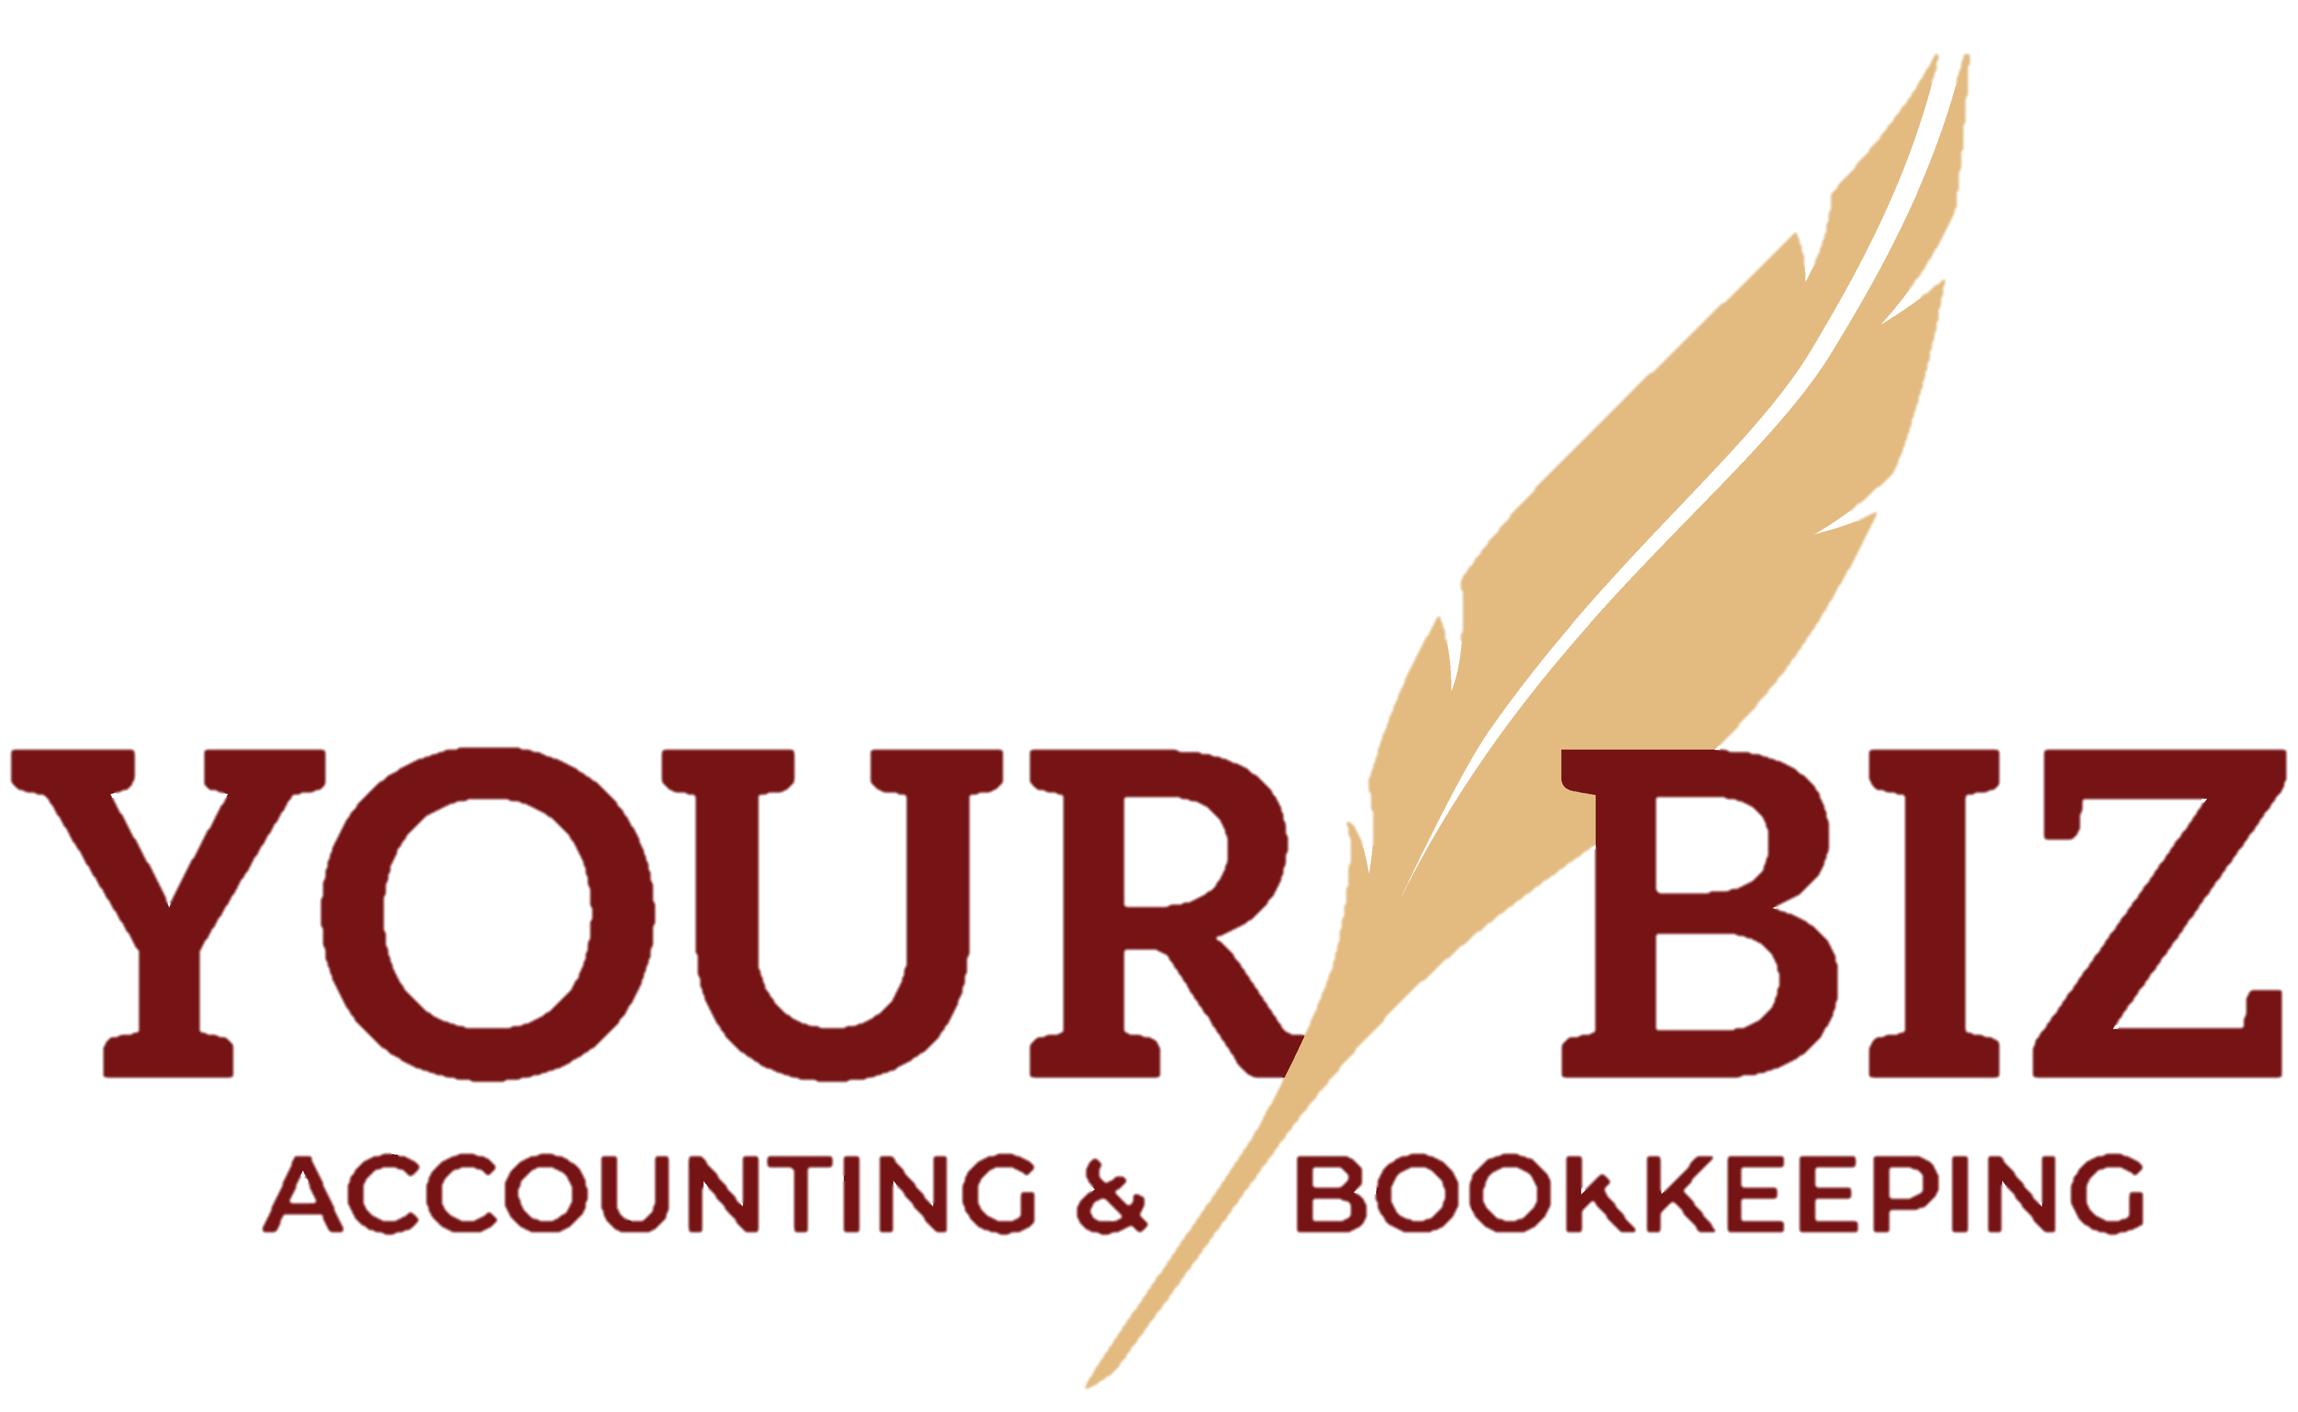
- Income protection insurance
- Tax agent fees
- Bank fees
If you are unsure of the deductions you may claim, please visit the following ATO website which outlines deductions you may claim
https://www.ato.gov.au/Individuals/Income-and-deductions/Deductions-you-can-claim/

Some of these documents may not be relevant to you if you are unsure, include them anyway.
Once all the documents are received, we will then commence your tax return.
Please contact us on 9306 2274 or admin@ybab.com.au if you have any queries.

